NODE Application Correction Documents

The following task are as follows:

1. Setup the original Mysql node js application

(link to download : <https://drive.google.com/file/d/1dcMHWJ9TP7vocjeHYCx0JvWO4_7zOjDY/view?usp=sharing> )

1. Setup the original Postgres node js application

(project available on github link: <https://github.com/sky1010/HUB_FRONT_END> &

<https://github.com/sky1010/HUB_BACK_END> )

1. Add global variable for port to have multiple instances running

The objective is to first set up 2 node js application in order to compare and correct errors. The list of errors are as follows:

Step to reproduce :

Login to the application then select “LeHUB PARAMETRES’’

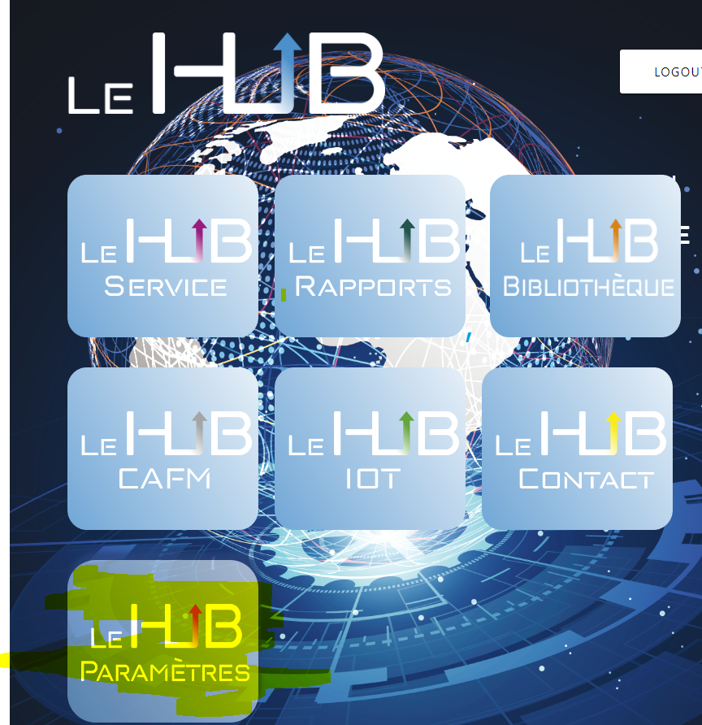

Then on this page you will see that the label are not showing due to APIs errors and translation error

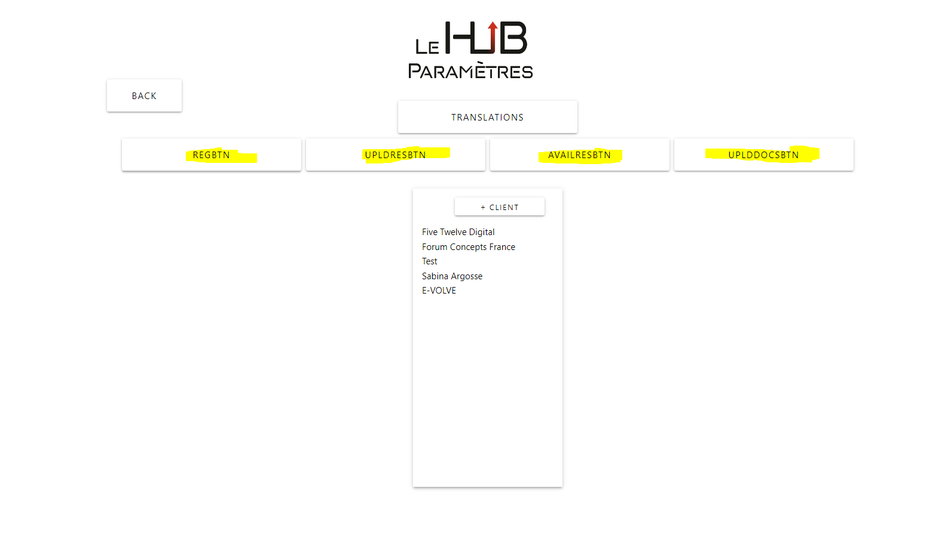

On the console these errors are displayed

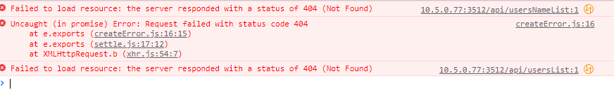

When you click on the REGBTN and try to register a user it works perfectly but the sequence on the database start at 1

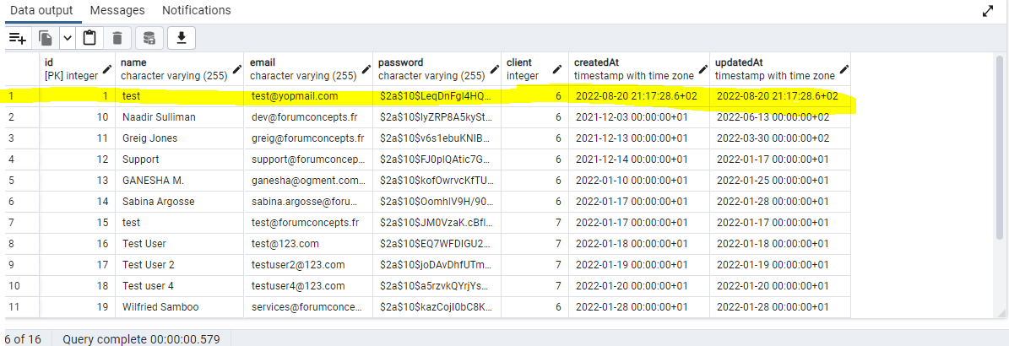

* When you click on the AVAILRESTBTN and you try to delete an item it keep loadings

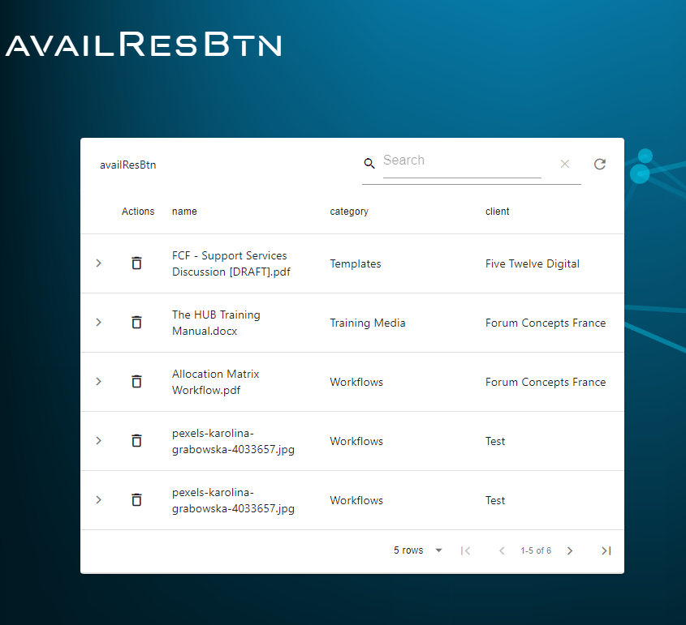

* On the homepage you need to go on LHUB BIBLIOTHEQUE

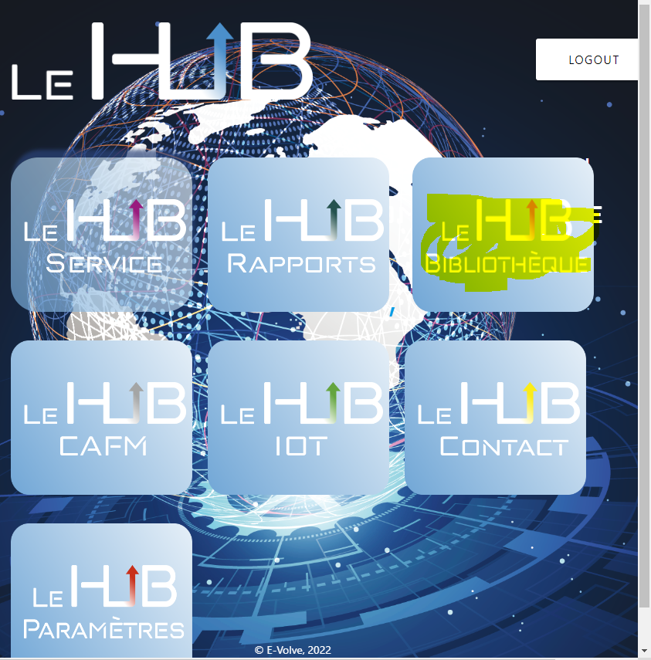

On this page if you click on any of the boxes the error below will pop

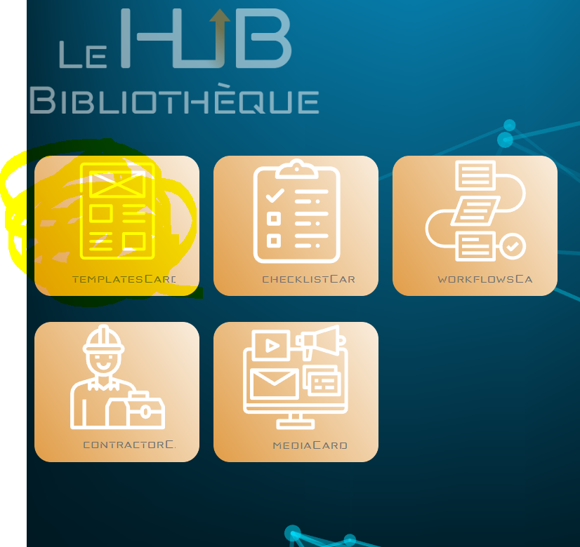

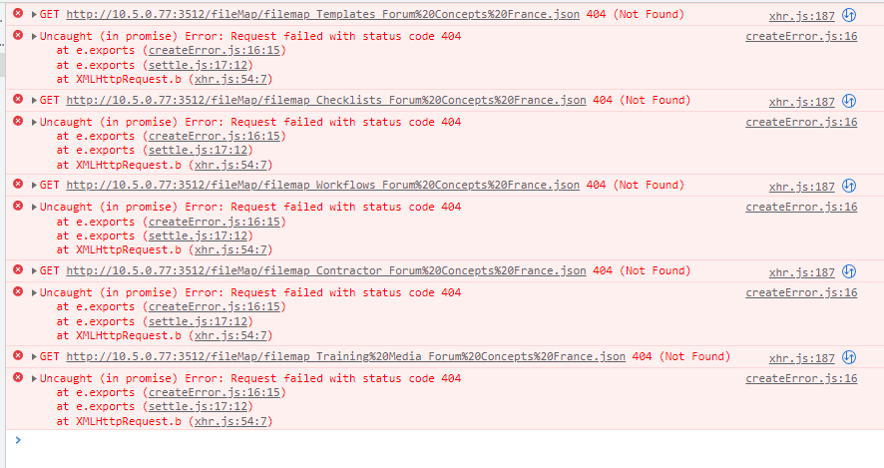

Any Questions feel free to what Apps me :)